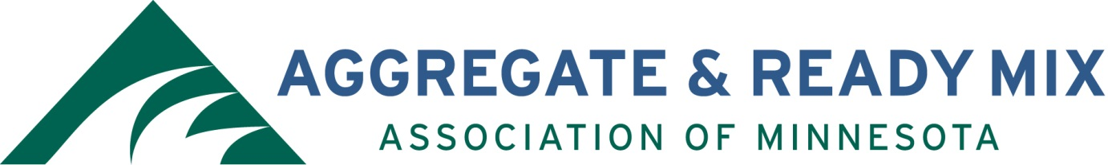

ARM of MN Scholarship Guidelines

Two awards of $2,000.00 each will be made yearly.

$2,000 Annual Engineering Scholarship:
Eligible students must be currently enrolled in civil or construction engineering program at:
University of Minnesota (Twin Cities)
Minnesota State University – Mankato
University of Minnesota – Duluth
University of St. Thomas

$2,000 Dave Edmunds Memorial Scholarship
Eligible students must be currently enrolled in a construction management or geology program at an accredited, four-year, college program within the State of Minnesota.

Recipient must use the scholarship during the school year following receipt of the award.

ARM’s Scholarship Committee shall review submittals during the last week of October 2021with a decision and notification of winners by November 5, 2021.

Presentation of winners will occur during the ARM Convention in Minneapolis on December 1.

Send the completed application to info@armofmn.com or mail to the address shown below.

Aggregate & Ready Mix Association of Minnesota (ARM)
Attn: Scholarship Committee
PO Box 211542
Eagan, MN 55121

Applications must be received via email or postmarked no later than October 18, 2021.

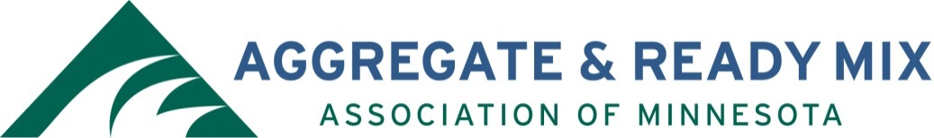

ARM of Minnesota Scholarship Application

Entry Date:
Student Name:
Street Address:
City, State, Zip:
Phone & Email:
Student’s Birth Date:
School Presently Attending:
Grade Point Average:
School Contact (name and phone number of a teacher or school official familiar with the student):
Extracurricular Activities (use separate sheet of paper if necessary):

Please provide a brief paragraph outlining your plans for advanced education and your long-term goals (use separate sheet of paper if necessary):

I have read the Aggregate Ready Mix Association of Minnesota Members Scholarship Guidelines on the preceding pages and agree to abide by them:

Student Signature Date

Please return completed application to the following address or email to info@armofmn.com. DEADLINE IS OCTOBER 18, 2021.

Aggregate & Ready Mix Association of Minnesota (ARM)
Attn: Scholarship Committee
PO Box 211542
Eagan, MN 55121

