Scheduling an Appointment Online through MavCONNECT

- Go to www.mnsu.edu/mavconnect.
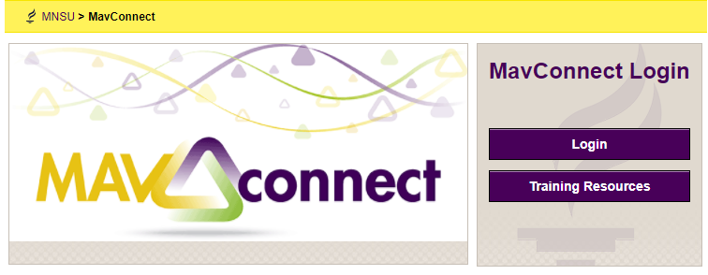
- Click on Login.

- Click on the Navigation (three lines) button and choose My Success Network.
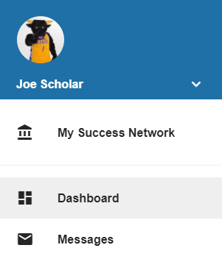

- Find the service (office) you want to meet with and click on Schedule. Based on your major, you will choose either CSET – Engineering and Technology majors or CSET Pre-Professional Programs and Natural Science majors as shown below.

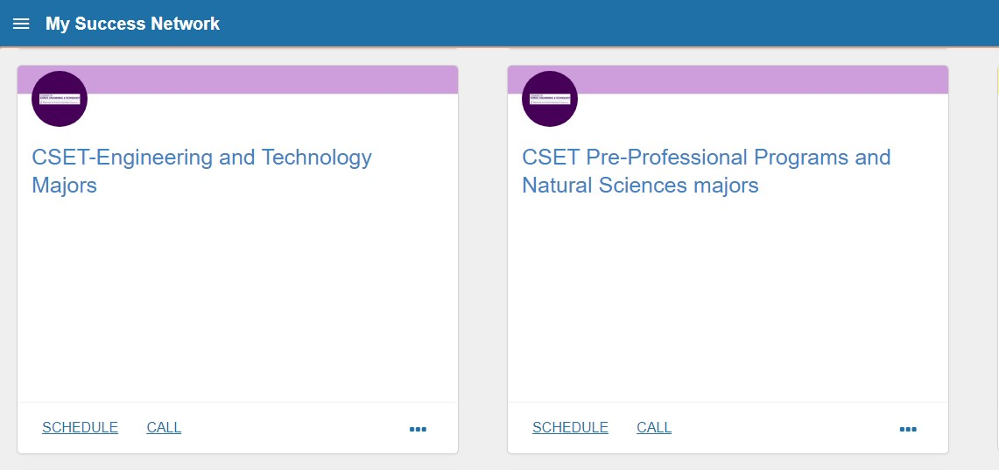

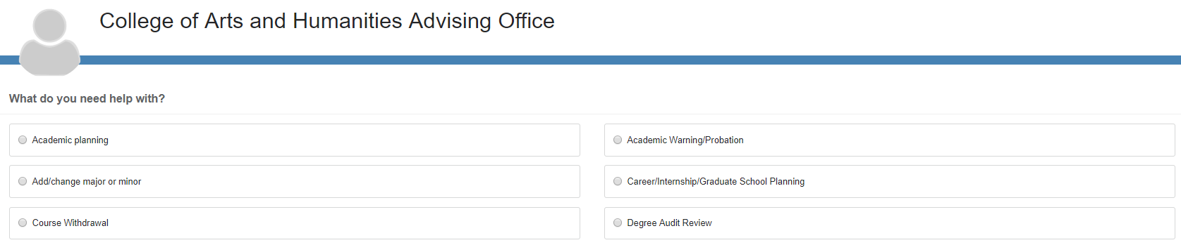
- Select the Reason for the appointment.

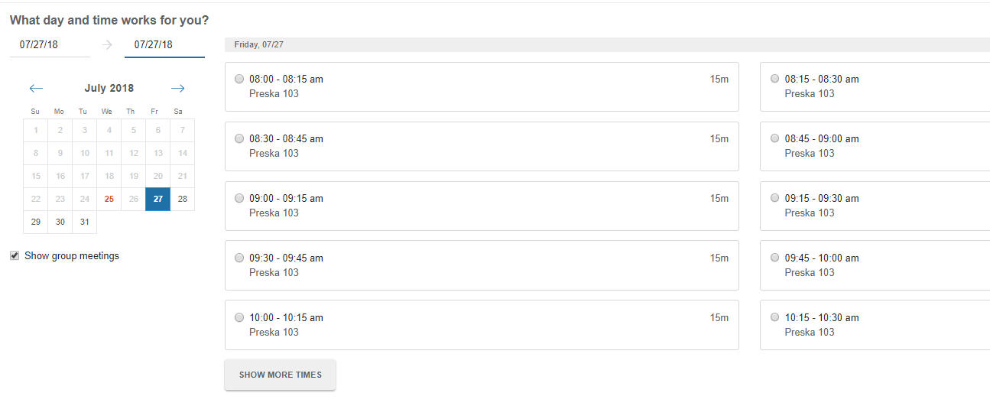
- Use the calendar and select a date for an appointment. Use the arrows to move to a new month if needed.

- Select a time for the appointment and click “Continue”

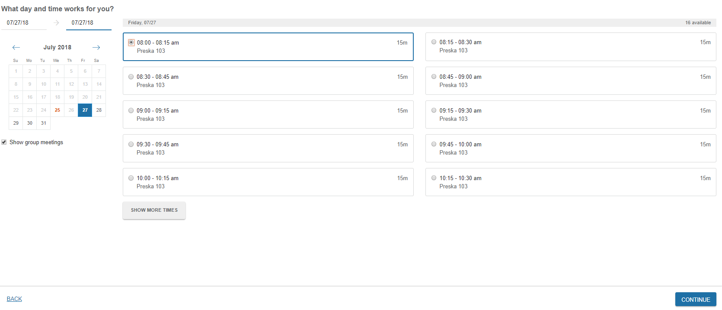

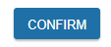
- Confirm that the date/time/reason look correct for your request and add any additional details that you want to share with your advisor prior to the meeting. Click Confirm to request the appointment. 