MT. SIMON AQUIFER MONITORING
Mankato-St. Peter Region

Overview
The Mt. Simon aquifer is the deepest bedrock aquifer in south central/southeastern Minnesota. It extends across southern Minnesota and south and east (see map). It is the most productive underground water source in the region and supplies water for over one million Minnesotans. Groundwater monitoring indicates declining levels in some parts of Minneapolis/St. Paul metro areas where water is being withdrawn for municipal and commercial use (and also regional declines west of Mankato). Significant research is underway by Minnesota Department of Natural Resources to better understand water use and recharge trends.

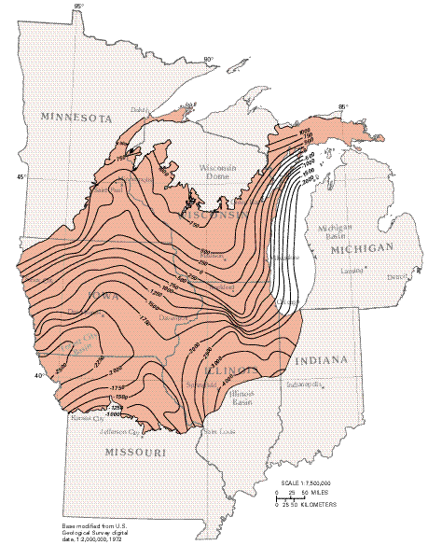

Map of the extent of the Mt. Simon Aquifer.Map source: USGS

Geology
The Mt. Simon is made of a kind of sedimentary rock called “sandstone”. This rock is permeable, which means that groundwater can flow inside of and through it. When the aquifer is saturated with enough water, communities can drill wells down to it and it can produce drinking water or water for industrial use. In some areas, the aquifer is underlain by another geologic formation called the Hinckley Sandstone. In areas where these two formations are laying on top of each other, they are called the Mt. Simon-Hinckley aquifer.

Mt. Simon Monitoring, Mankato-St. Peter Region

Minnesota Department of Natural Resources (MDNR) is the responsible agency for monitoring groundwater levels in Minnesota. You can learn about groundwater monitoring sites across the state by exploring the Cooperative Groundwater Monitoring website; https://www.dnr.state.mn.us/waters/cgm/index.html

Mt. Simon monitoring in the Mankato area is funded by the Mt. Simon Aquifer Monitoring Group, a partnership with six area MDNR permit holders. The vision for this regional Mt. Simon aquifer monitoring is to track water levels long term to ensure sustainable use of the groundwater resource. Taking water level measurements on a regular basis over a long time period will tell us whether water levels have changed significantly. This can help us spot and address groundwater recharge issues.

Monitoring Locations

There are three wells monitored the Mt. Simon aquifer in the Mankato—St. Peter area:
- Lake Crystal (Loon Lake),
- St. Peter (Seven Mile Creek Park), and
- Mankato (Sibley Park).

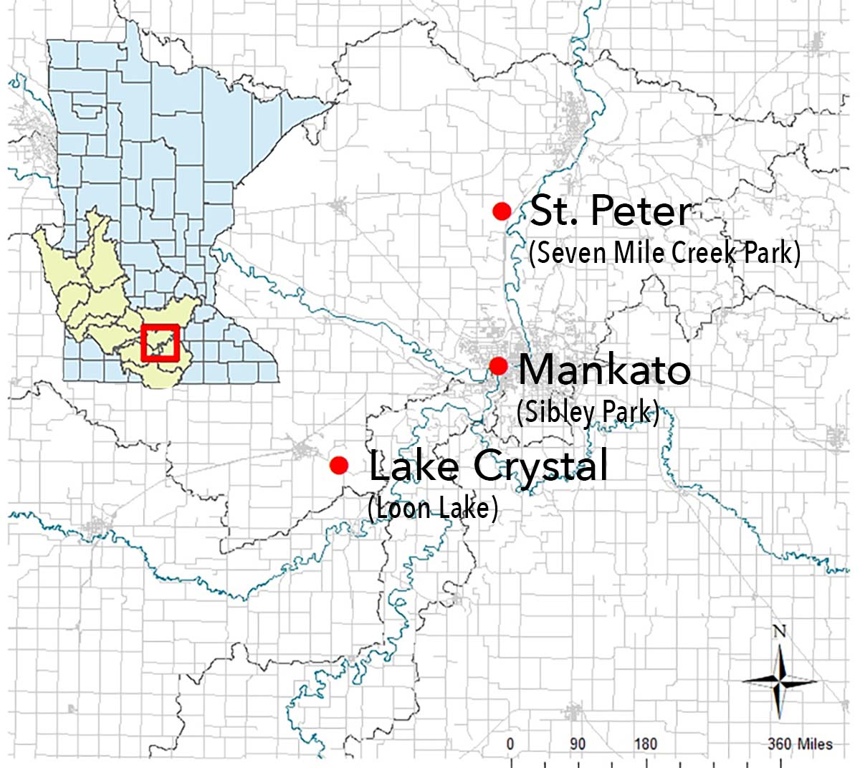

Monitoring Methods
Each monitoring well was drilled on public land to ensure the longevity of these monitoring sites. Different monitoring equipment is being used to get a consistent water level record in the wells. Two different types of sensors were installed at the sites: Loon Lake and Seven Mile have level troll sensors and Sibley Park has a vibe wire sensor. They function a little differently and have different maintenance requirements. These sites have been monitored since fall 2012.

Monitoring Results
You can view the monitoring results for each of these sites on MDNR’s Department of Natural Resources Cooperative Groundwater Monitoring website: https://www.dnr.state.mn.us/waters/cgm/index.html

Lake Crystal (Loon Lake): https://www.dnr.state.mn.us/waters/cgm/site.html?id=793259
St. Peter (Seven Mile Creek Park) - https://www.dnr.state.mn.us/waters/cgm/site.html?id=793257
Mankato (Sibley Park)

Groundwater monitoring is important to maintain over long time frames. Not enough data has been collected yet to illustrate long term trends. Short term data indicates fairly stable conditions.

For More Information
Department of Natural Resources Cooperative Groundwater Monitoring website:https://www.dnr.state.mn.us/waters/cgm/index.html

Mt. Simon Reports
Phase I: Berg J.A. and Pearson S.R. South-Central Minnesota Groundwater Monitoring of the Mt. Simon Aquifer. Minnesota Department of Natural Resources. 2011. http://www.lccmr.leg.mn/projects/2008/finals/2008_04h1_rpt_mt_simon_groundwater_monitori ng.pdf
Phase II: Berg J.A. and Pearson S.R. South-Central Minnesota Groundwater
Monitoring of the Mt. Simon Aquifer – Phase 2. Minnesota Department of Natural Resources. 2012. http://www.lccmr.leg.mn/projects/2009/finals/2009_03b2_rpt_monitoring-mt-simonaquifer_ph2.pdf
Pearson S, Falteisek J., and Berg J. Minnesota Groundwater Level Monitoring Network – Guidance Document for Network Development. Minnesota Department of Natural Resources. 2011. http://www.lccmr.leg.mn/projects/2008/finals/2008_04h1_rpt_groundwater_guidance_document .pdf

