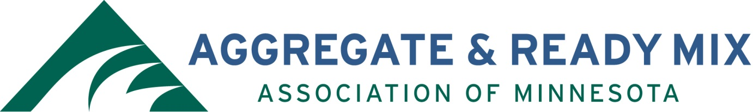

ARM of MN Scholarship Guidelines

Two awards of $2,000.00 each will be made yearly.

$2,000 Annual Engineering Scholarship:
Eligible students must be currently enrolled in civil or construction engineering program at:
University of Minnesota (Twin Cities)
Minnesota State University – Mankato
University of Minnesota – Duluth
University of St. Thomas

$2,000 Dave Edmunds Memorial Scholarship
Eligible students must be currently enrolled in a construction management or geology program at an accredited, four-year, college program within the State of Minnesota.

Recipient must use the scholarship during the school year following receipt of the award.

ARM’s Scholarship Committee shall review submittals with a decision and notification of winners by January 30, 2020.

Send the completed application to info@armofmn.com or mail to the address shown below.

Aggregate & Ready Mix Association of Minnesota (ARM)
Attn: Scholarship Committee
PO Box 211542
Eagan, MN 55121

Applications must be received via email or postmarked no later than December 11, 2020.

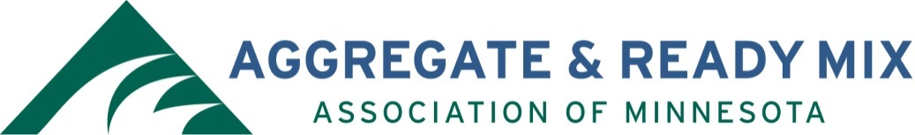

ARM of Minnesota Scholarship Application

Entry Date:
Student Name:
Street Address:
City, State, Zip:
Phone & Email:
Student’s Birth Date:
School Presently Attending:
Grade Point Average:
School Contact (name and phone number of a teacher or school official familiar with the student):
Extracurricular Activities (use separate sheet of paper if necessary):

Please provide a brief paragraph outlining your plans for advanced education and your long-term goals (use separate sheet of paper if necessary):

I have read the Aggregate Ready Mix Association of Minnesota Members Scholarship Guidelines on the preceding pages and agree to abide by them:

Student Signature Date

Please return completed application to the following address or email to info@armofmn.com. DEADLINE IS December 11, 2020

Aggregate & Ready Mix Association of Minnesota (ARM)
Attn: Scholarship Committee
PO Box 211542
Eagan, MN 55121

